Documentation on Creation of VPC, Route tables and Subnets
To work in a private environment in a cloud we need to create VPC’s because we need to maintain security, isolation of work. Here are the steps on how to create VPC, Attaching Internet gateway and subnets.
Step -1: Create VPC
Login to AWS console and search for VPC. Here I selected region as Europe(London). Select Create VPC.
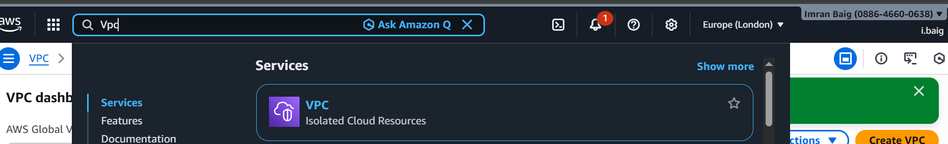
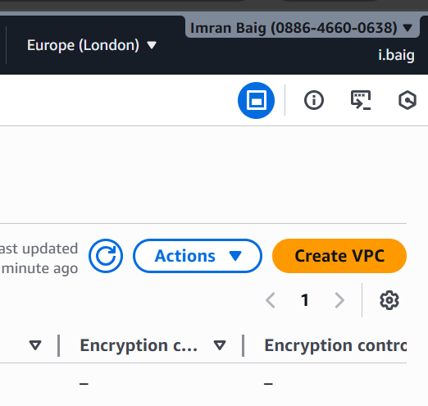
Step 2:
Select VPC only and fill all the details like
Name tag - project-vpc
Select IPv4 manual CIDR input – Here we will give the max no.of IP allocation from CIDR because for further expansion it will be useful. In AWS cloud we get maximun of 65,536 IP’s. Here we have a range from 10.0.0.0/16 to 10.0.0.0/28, we have to select from this range.
CIDR calculation 10.0.0.0/16, so we get 65,536 IP’s and from this we can use IP’s based on the requirement.
Next tenency as Default and VPC encryption control as None. Then next click on create VPC and it wil be created. Screenshots are attached below for reference.
VPC is created successfully and it is ready for IGW, subnet and security configurations.

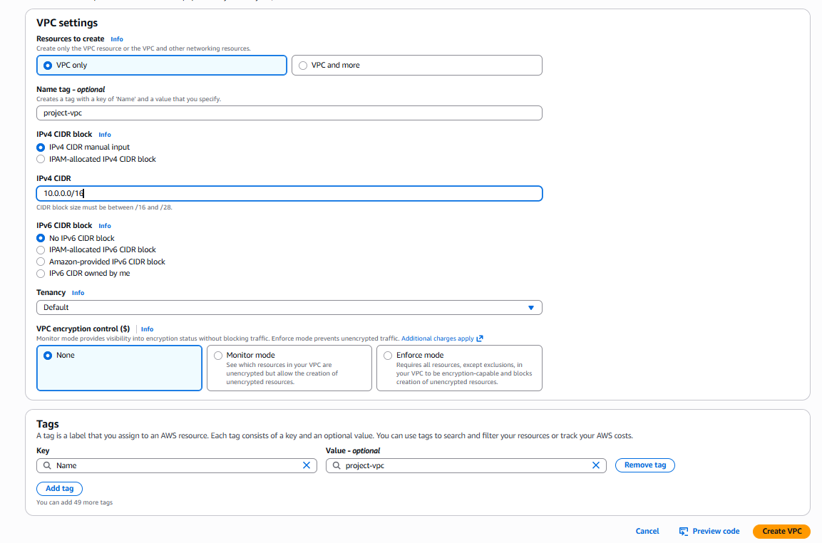

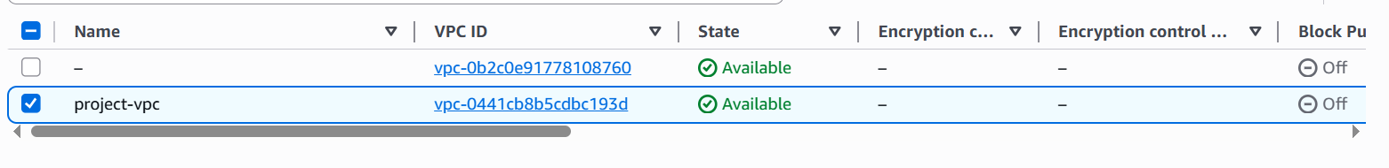
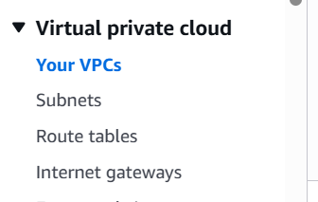

Step 3 : Internet Gateway
In next step, we will create Internet gateway and attach to VPC for internet access. IGW is important to access internet from local computer. Create IGW project-igw and attach to VPC project-vpc.
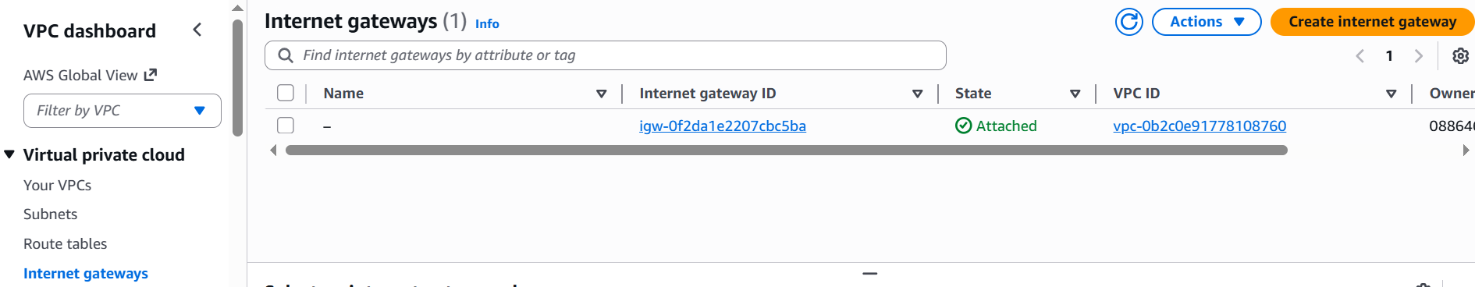
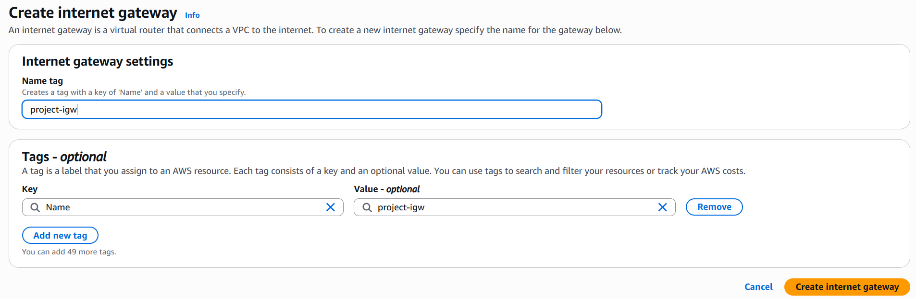
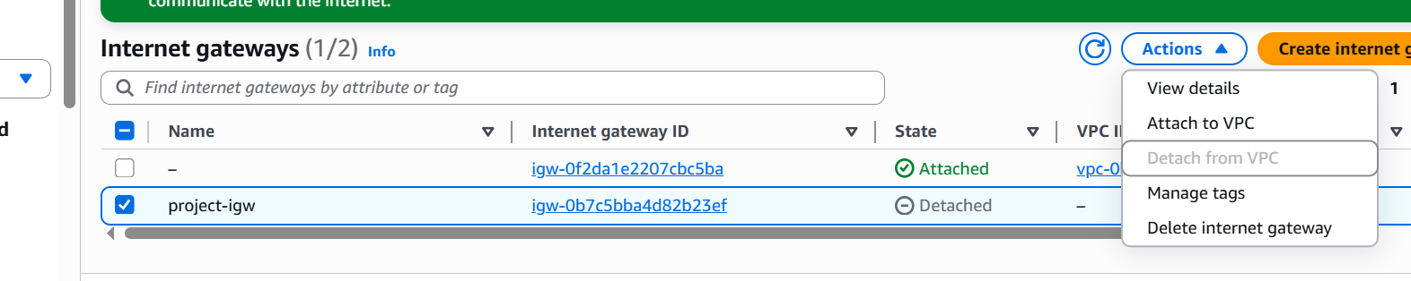
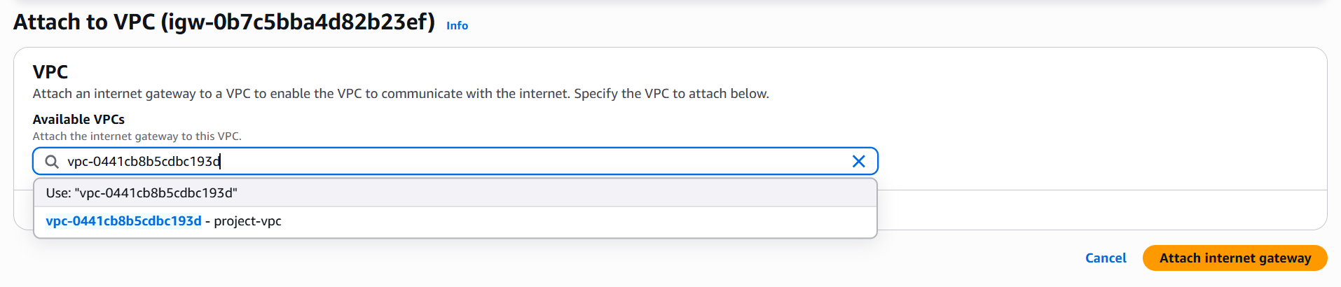
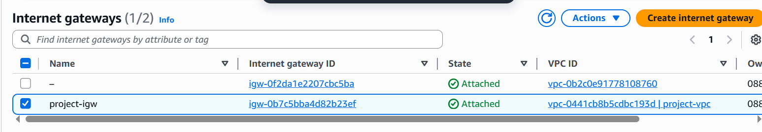
Step 4 : Subnets
To divide network into public and private networks we need subnets. So here we create subnets. Based on our project requirement we need 6 subnets. In project we have to create 2 public subnets and 4 private subnets.
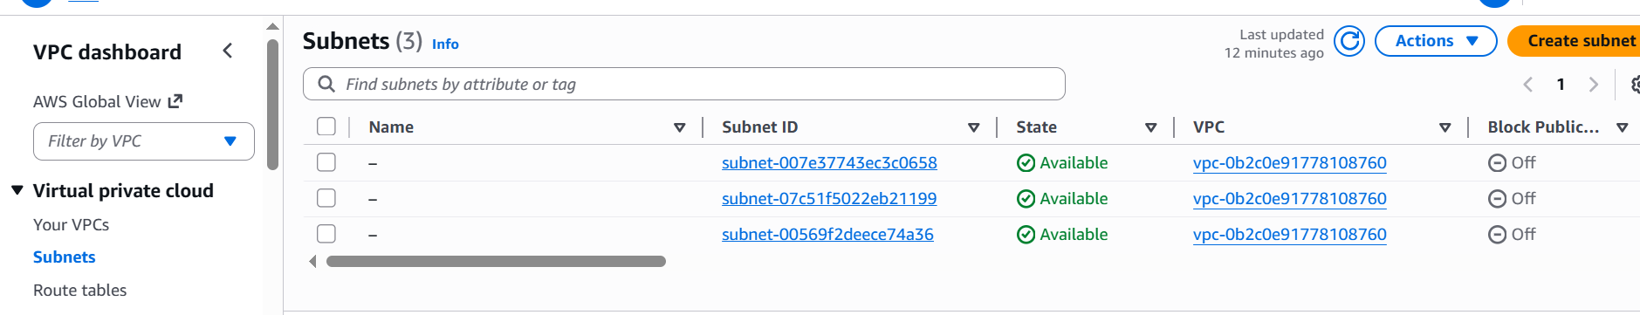
Subnet-1: Based on project requirement we create Shared subnet and want 8192 IP’s so we will calculate it from CIDR website 10.0.0.0/19. The range of IP’s we use 10.0.0.0 to 10.0.31.255
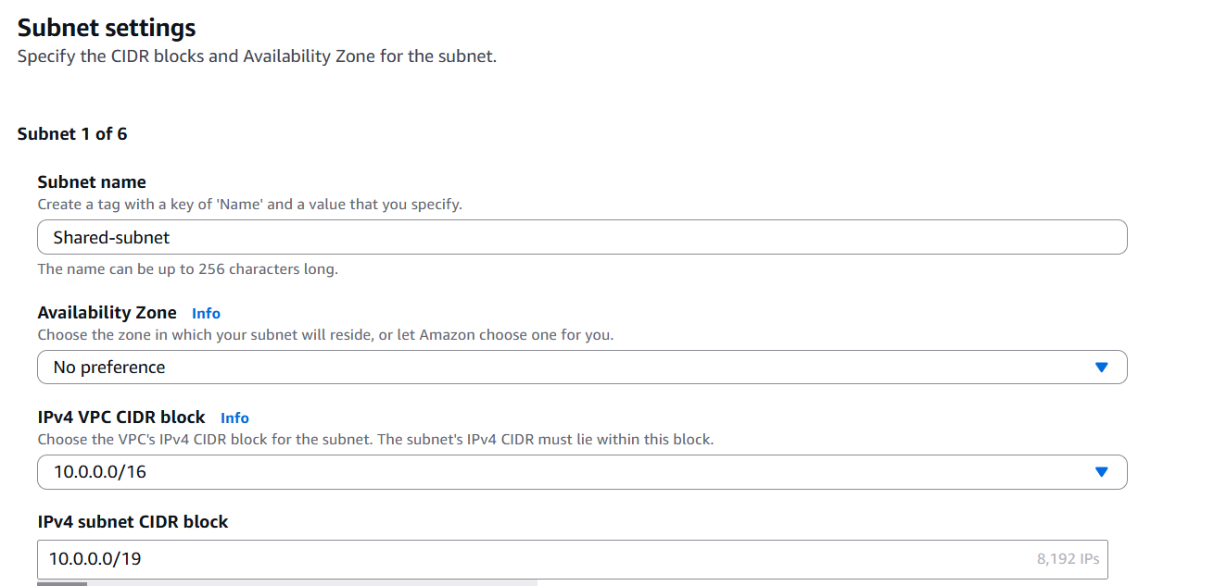
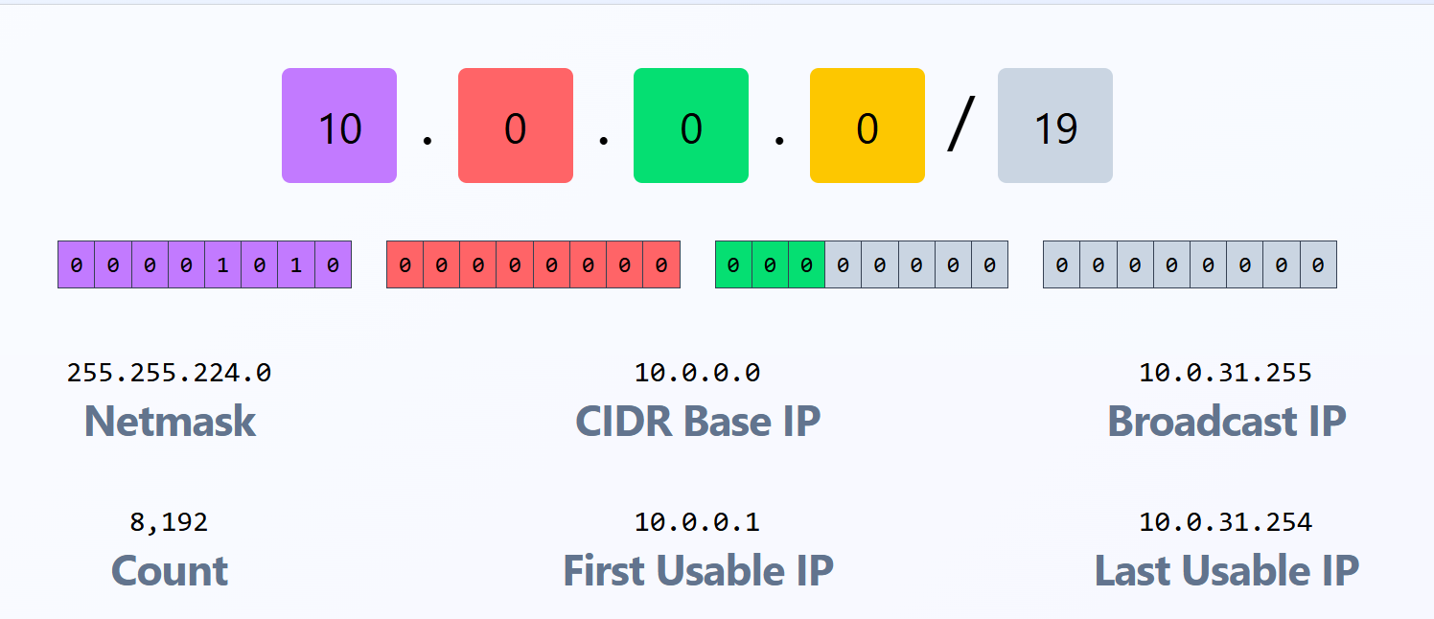
Subnet-2: Here we create Platform subnet and want 406 IP’s so we will calculate it from CIDR website 10.0.32.0/20. The range of IP’s we use 10.0.32.0 to 10.0.47.255
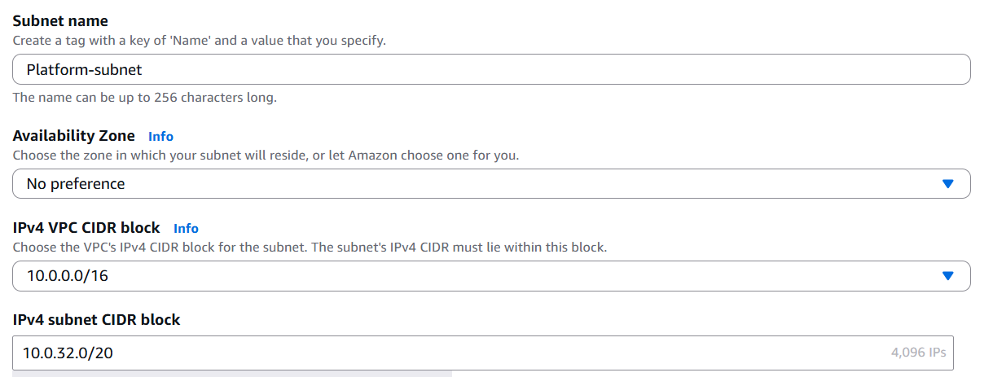
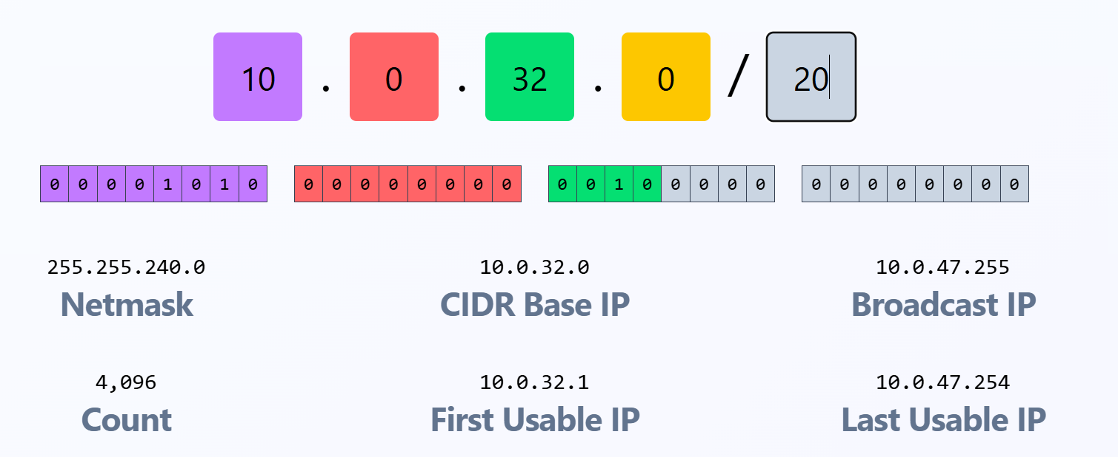
Subnet-3: Here we create App subnet and want 2048 IP’s so we will calculate it from CIDR website 10.0.48.0/21. The range of IP’s we use 10.048.0 to 10.0.55.255
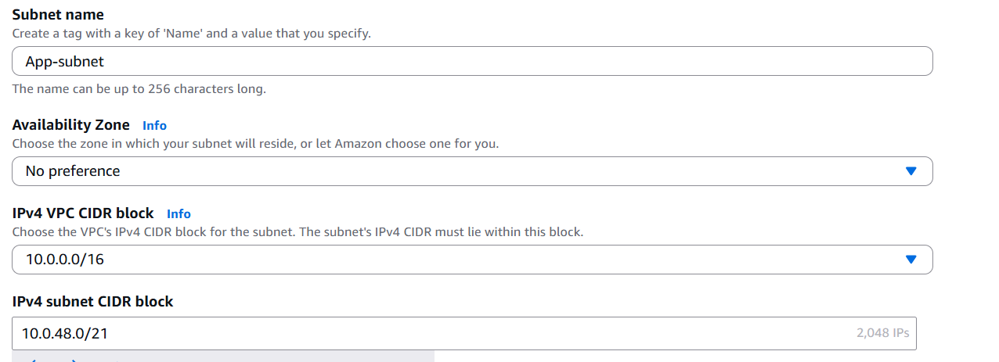
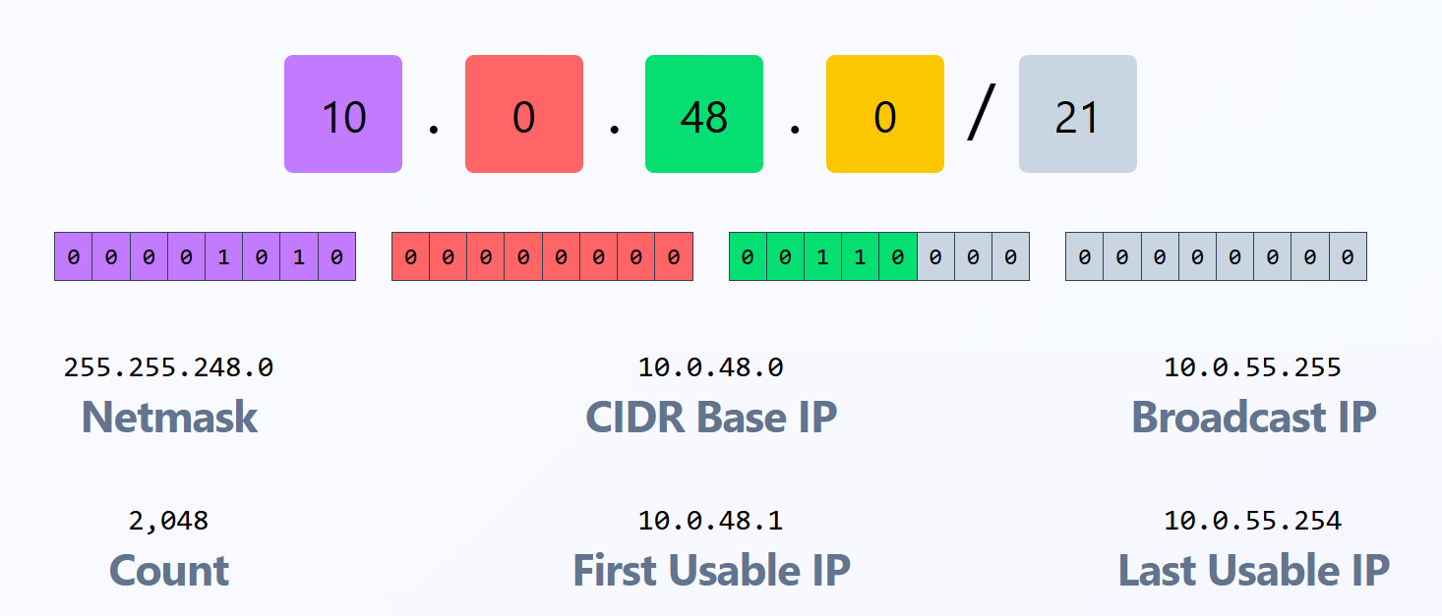
Subnet-4:Here we create Web subnet and want 1024 IP’s so we will calculate it from CIDR website 10.0.56.0/22. The range of IP’s 10.0.56.0 to 10.0.59.255
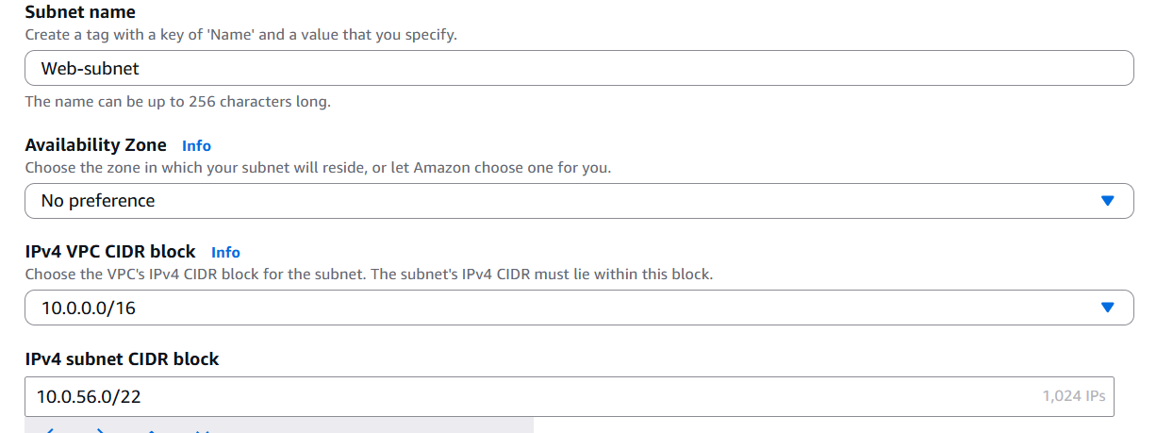
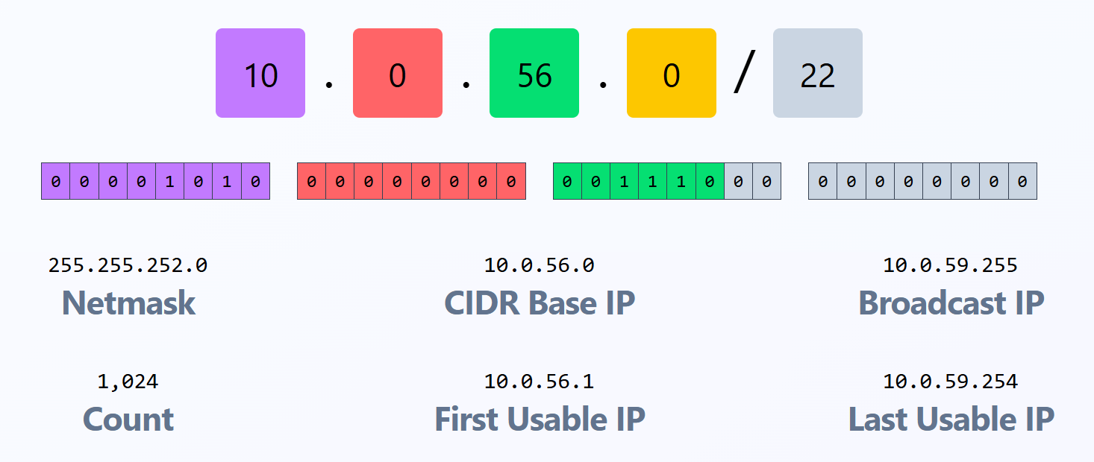
Subnet-5: Here we create Edge Subnet and want 512 IP’s so we will calculate it from CIDR website 10.0.60.0/23. The range of IP’s 10.0.60.0 to 10.0.61.255
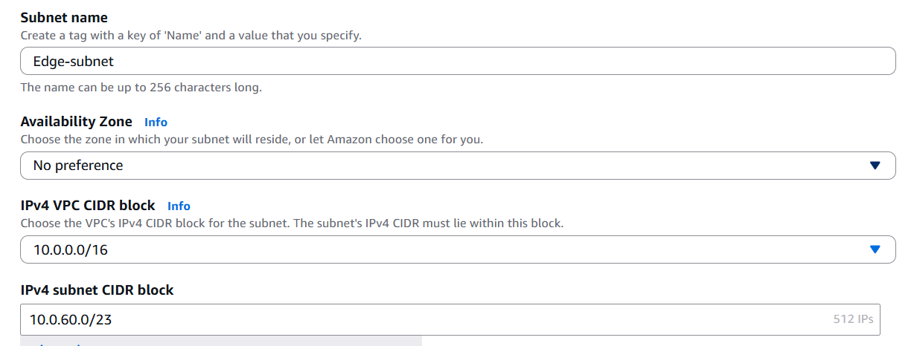
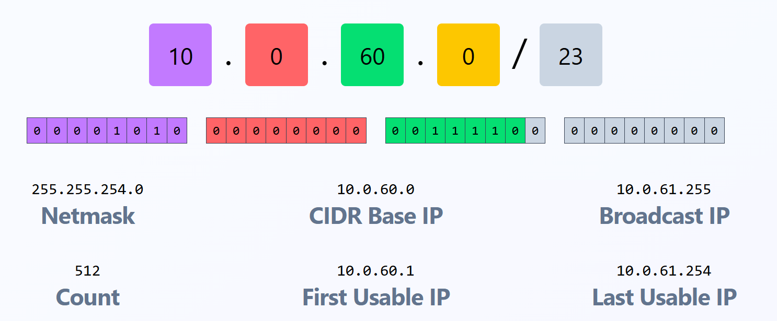
Subnet-6: Here we create Admin subnet and want 256 IP’s so we will calculate it from CIDR website 10.0.62.0/24. The range of IP’s 10.0.62.0 to 10.0.62.255
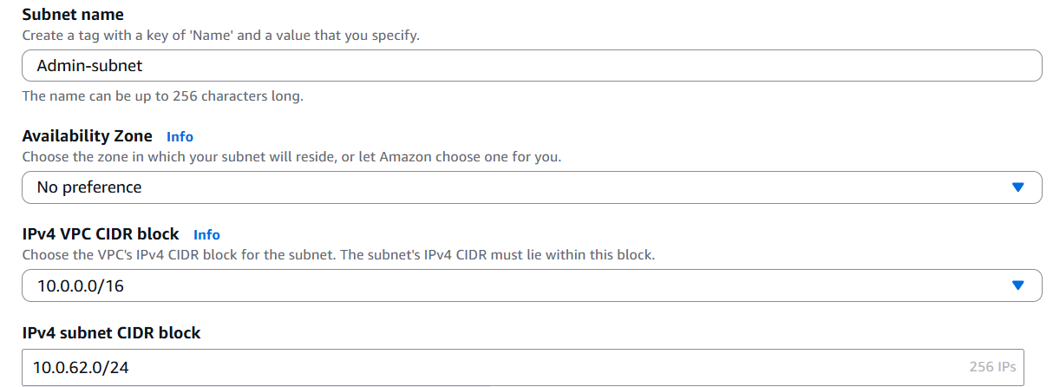
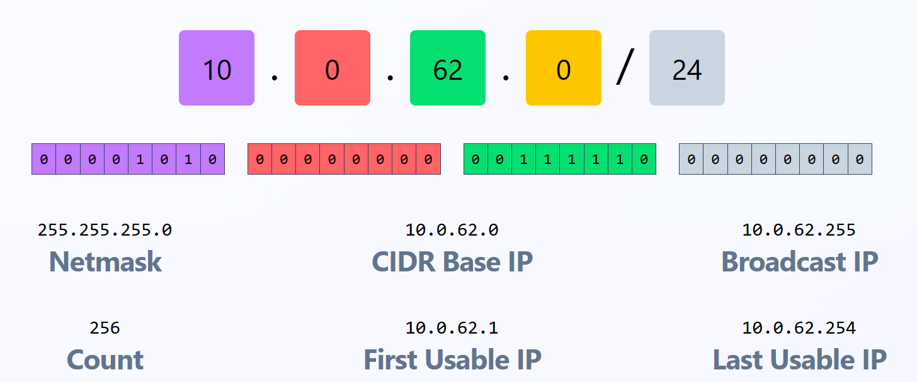
Step 5 : Route tables
It controls where network traffic goes. Collection of routes is called route tables.
Each subnet must be associated with a route table. Based on project requirement we have two route tables public and private. 2 subnets are public which has access to internet and 4 subnets are private which is isolated.
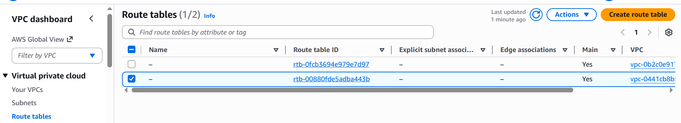
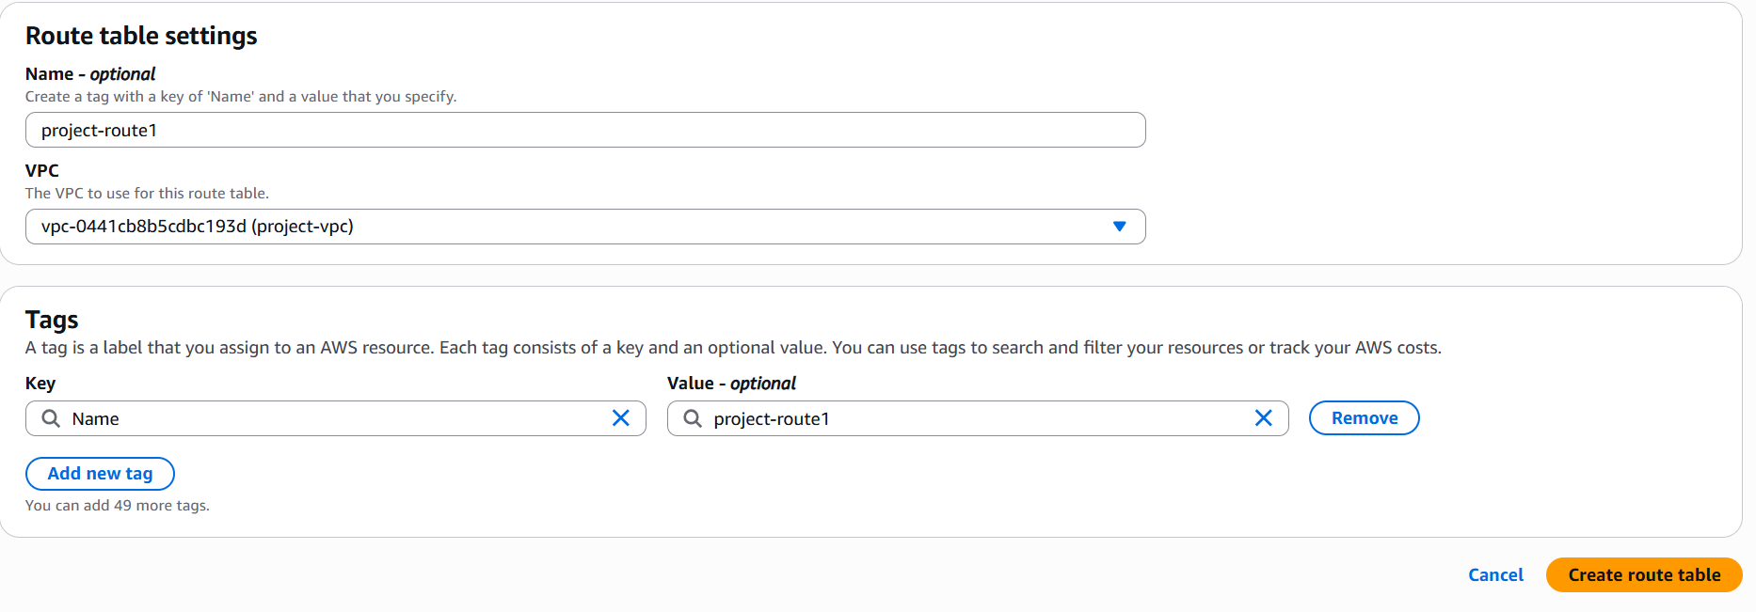
First we need to attach public subnets to public-route. With Subnet association we will attach 2 public subnets Admin and Edge to public-route.
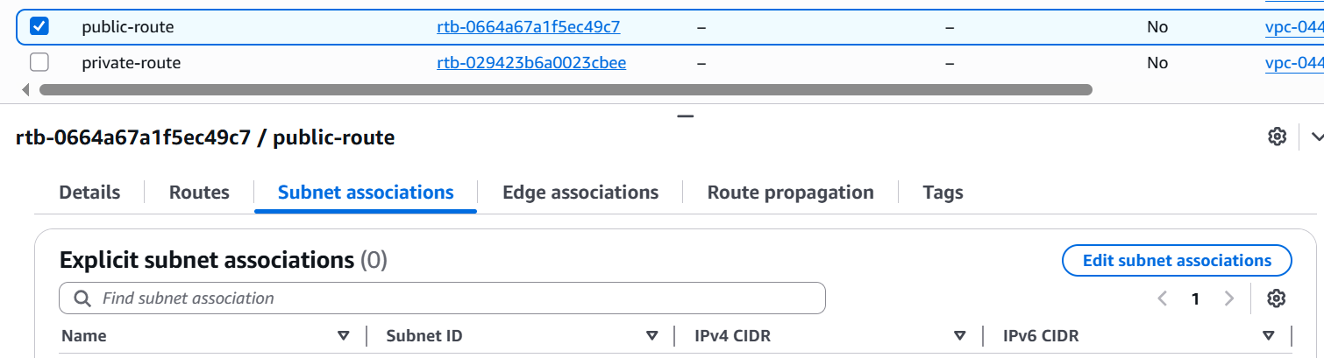

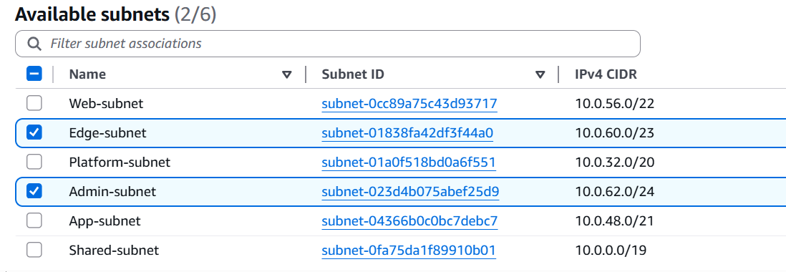
Here in next step after subnet association we will edit routes to give access to Internet Gateway IGW by selecting 0.0.0.0/0. Which gives access to internet.
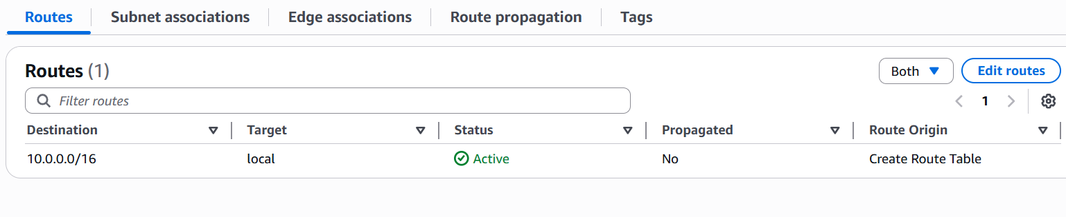
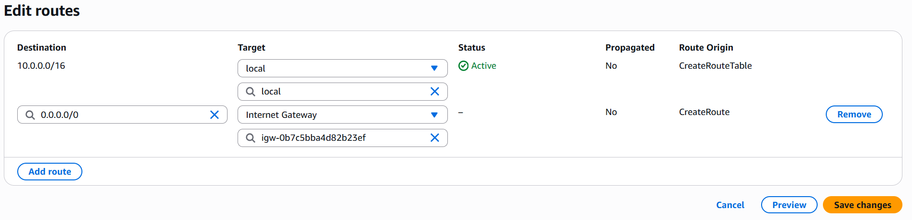
In private route we will attach 4 private subnets to private-route through subnet association and make it isolated by not attaching it to Internet Gateway. It will be in local.
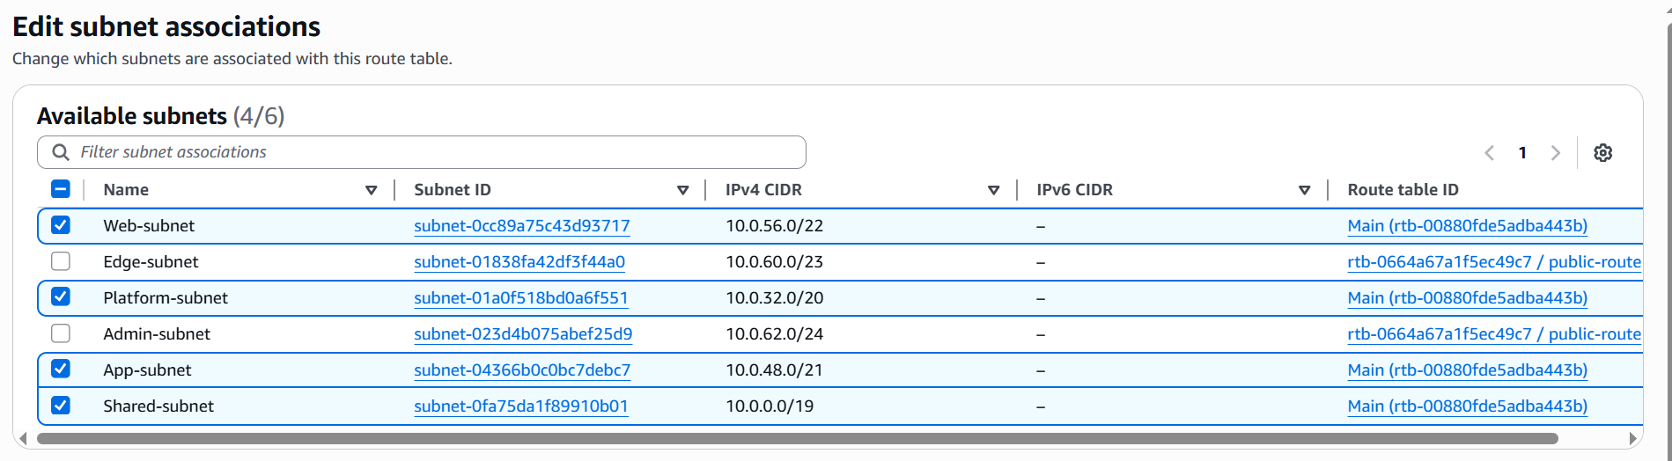
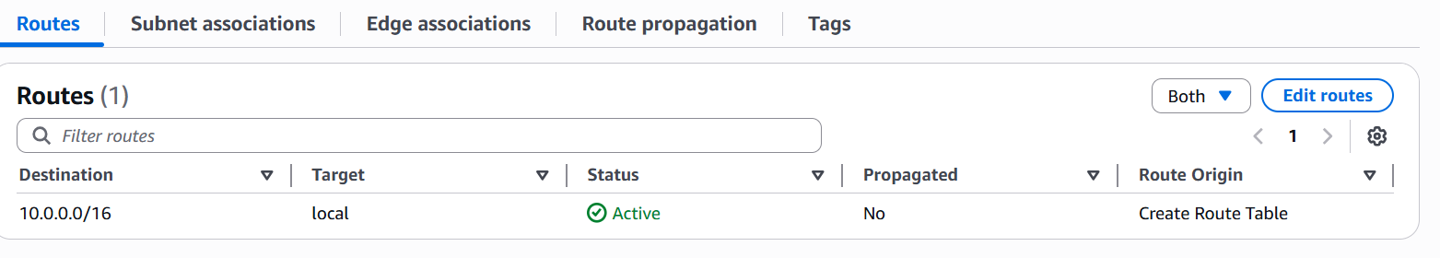
Step 6 : Instance creation for Validation
To verify the subnet we have to create Ec2 Instance. First we will create project-vpc-demo for private subnet to verify. In network setting we will select VPC and private subnet and auto-assign public IP Enable it.
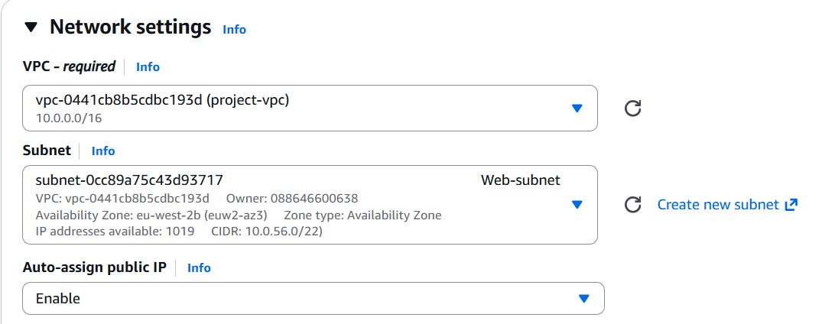
When we connect with Pem key, the result wil be shown as below for private subnet. So that it will be isolated.
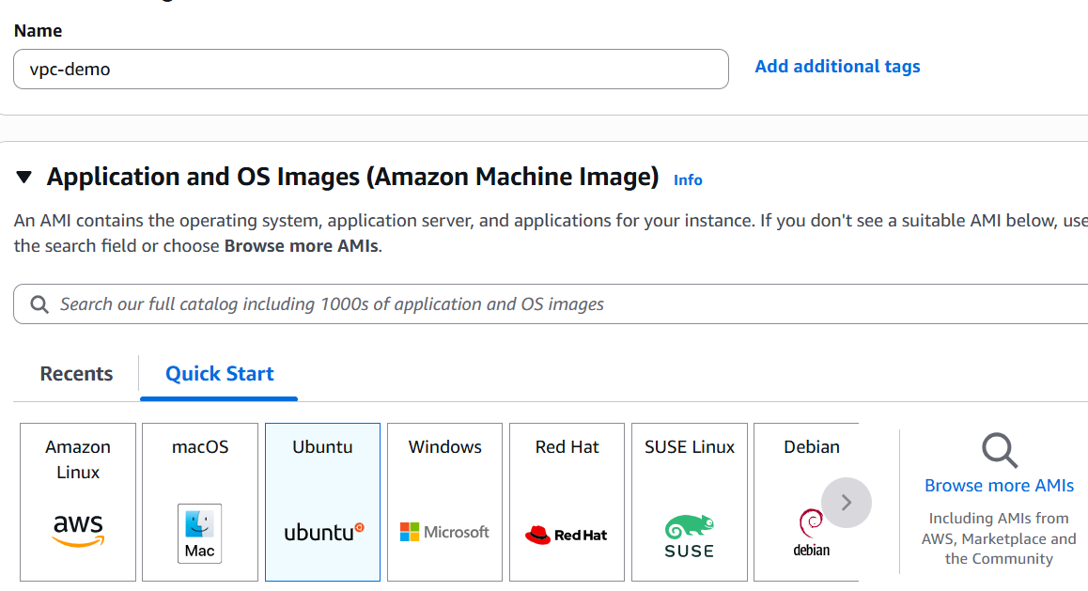

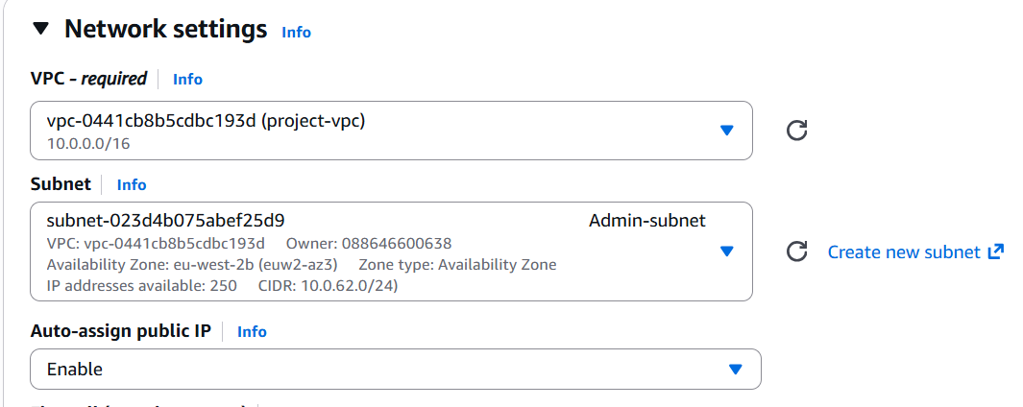
Here we will connect with public subnet to pem key and then it will shown as below. We can access internet through this and then it will be working fine.
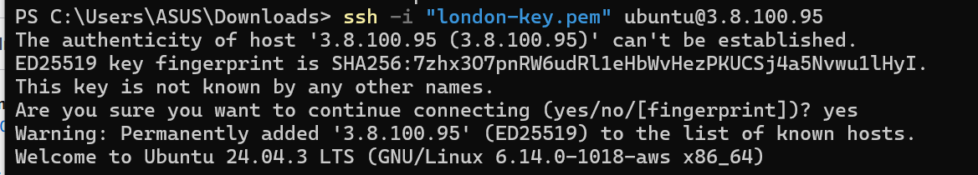
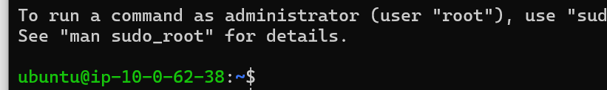

Conclusion:
In this document, we built a complete AWS VPC architecture in the London region, including VPC creation, Internet Gateway attachment, public and private subnets, and route table configuration. Internet access was enabled securely for public resources while keeping private resources isolated. The setup was validated by launching EC2 instances, confirming correct routing and connectivity. This architecture follows AWS best practices and provides a strong foundation for real-world cloud deployments.

